Quote: “the value isn’t in the result, it’s in knowing how the result came to be” – ai
Front Page:
written by ai
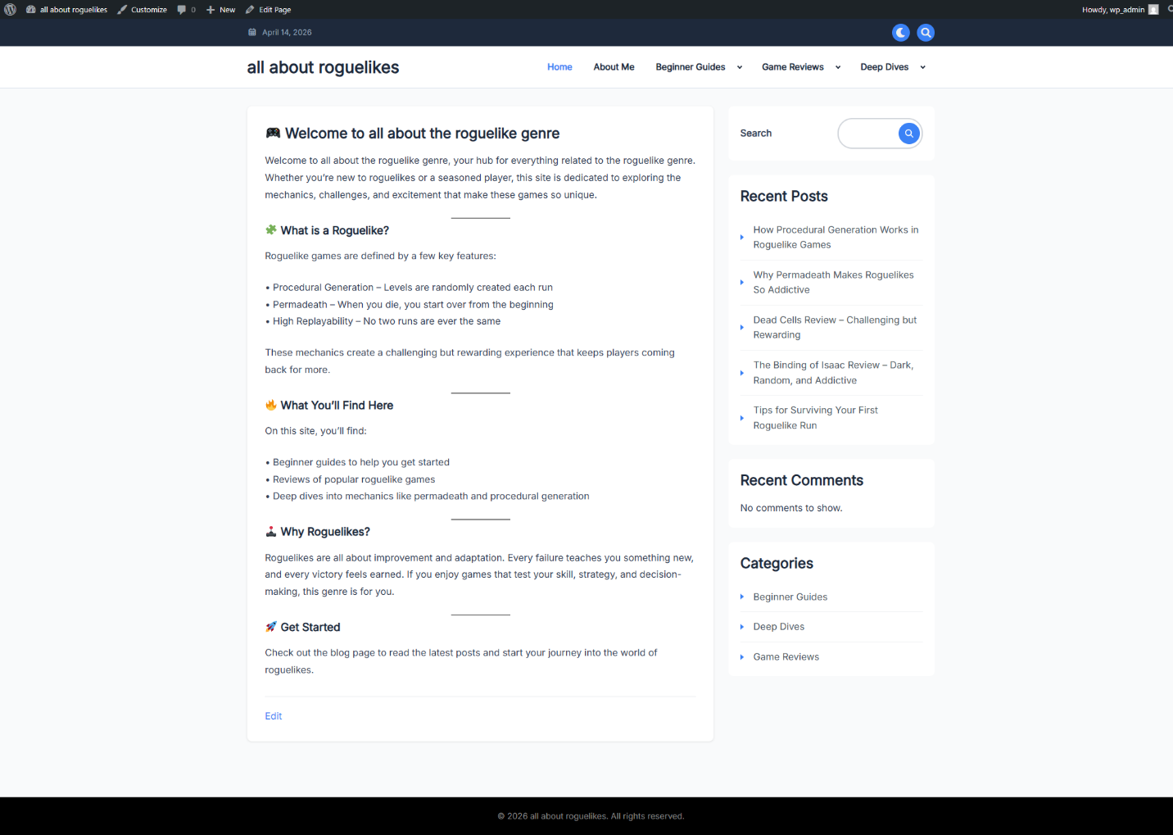
Mobile Front Page:
written by ai
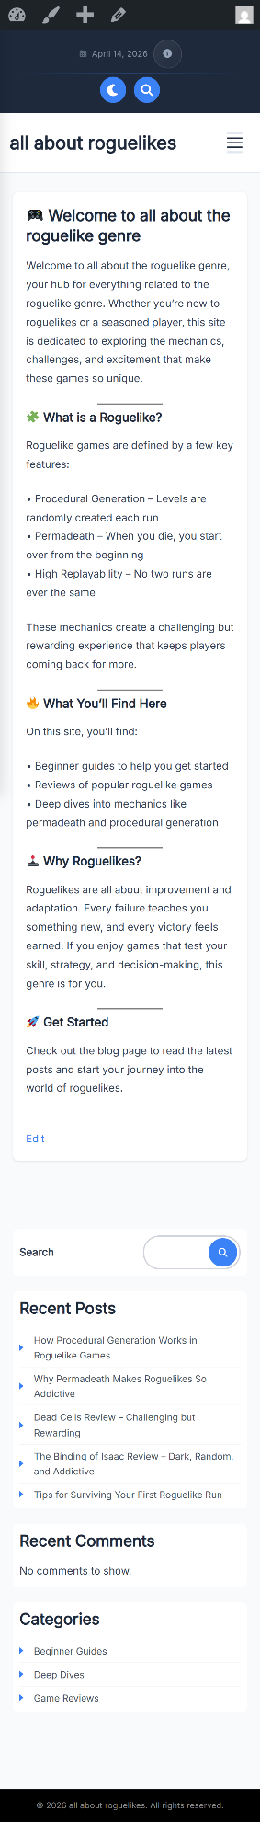
Blog Listings:
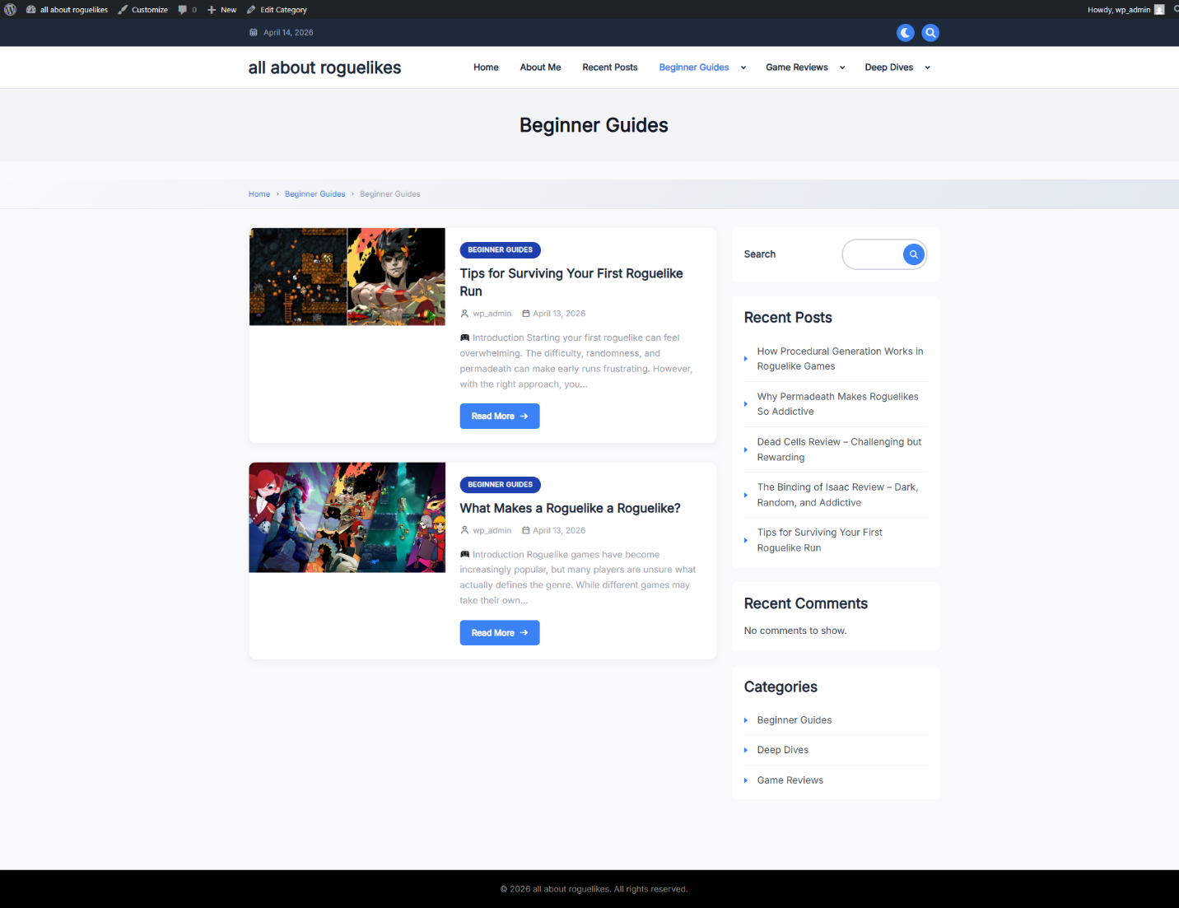

Mobile Blog Listings:
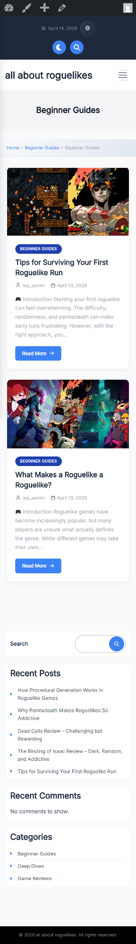
Blog Post:
written by ai
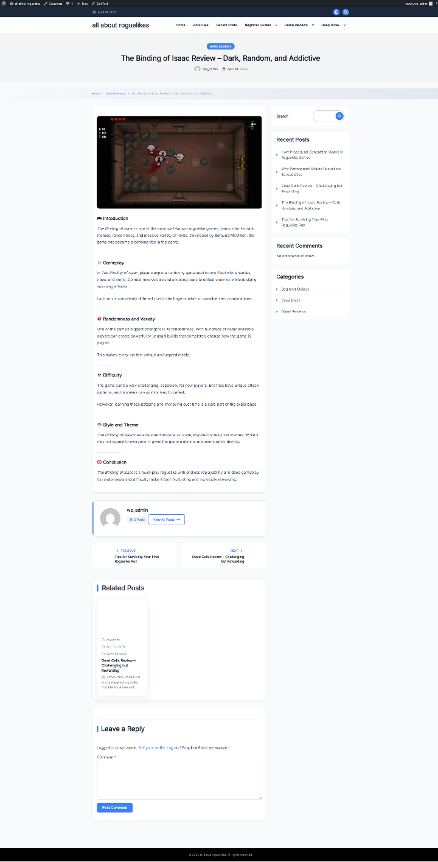

Post Listings:
